Introduction to PWM
Pulse width modulation (PWM) is a powerful technique for controlling analog circuits with a microprocessor's digital outputs. PWM is employed in a wide variety of applications, ranging from measurement and communications to power control and conversion. By controlling analog circuits digitally, system costs and power consumption can be drastically reduced. What's more, many microcontrollers and DSPs already include on-chip PWM controllers, making implementation easy.
The power through a device is proportional to the voltage supplied. Therefore, to decrease the power usage of a device (to dim an LED or to slow a motor), the duty cycle of the PWM signal should be decreased. A PWM signal can be used to limit the power to a device to save energy. This technique is used in many portable devices which have limited battery power.

PWM Uses for: 1) To digitally create an analog output voltage level for control functions (Motor speed control)and power supplies. 2) To digitally create analog signals for arbitrary waveforms, sounds, music and speech.

Power transfer to load by liner method and PWM method:

Liner method ( for example: potansiyometre):
Linear amplifiers vary the resistance of a pass element to regulate power. Efficiency is fine at the extremes — losses are minimal when R = 0 or very lage values , but suffers elsewhere, bottoming
out at midrange (R = RL) where the amount of energy wasted as heat in the amplifier equals that delivered to the load.

PWM:
The output of a PWM amplifier is either zero or tied to the supply voltage, holding losses to a minimum. As the duty cycle changes to deliver more or less power, efficiency remains essentially constant
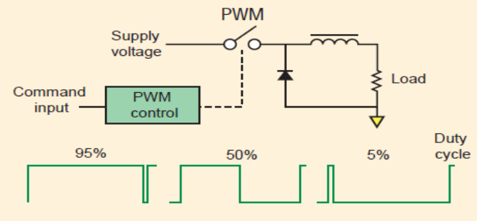
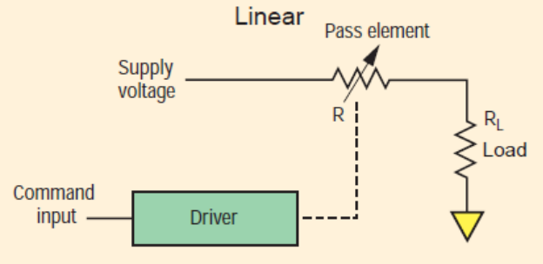

PWM, is a method of controlling the amount of power to a load without having to dissipate any power in the load driver. Imagine a 10W light bulb load supplied from a battery. In this case the battery supplies 10W of power, and the light bulb converts this 10W into light and heat. No power is lost anywhere else in the circuit. If we wanted to dim the light bulb, so it only absorbed 5W of power, we could place a resistor in series which absorbed 5W, then the light bulb could absorb the other 5W. This would work, but the power dissipated in the resistor not only makes it get very hot, but is wasted. The battery is still supplying 10W.
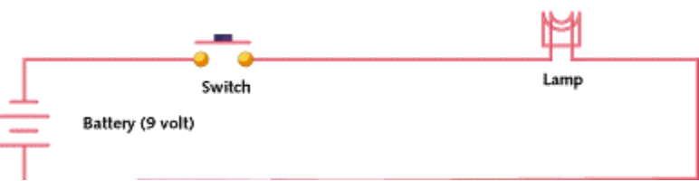
Power supply
Figure 1

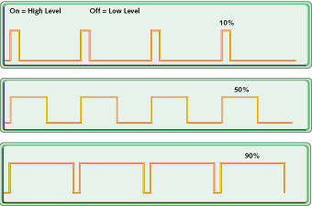
Figure 2: PWM signals of varying duty cycles
An alternative way is to switch the light bulb on and off very quickly so that it is only on for half of the time. Then the average power taken by the light bulb is still only 5W, and the average power supplied by the battery is only supplying 5W also. If we wanted the bulb to take 6W, we could leave the switch on for a little longer than the time it was off, then a little more average power will be delivered to the bulb.
This on-off switching is called PWM. The amount of power delivered to the load is proportional to the percentage of time that the load is switched on. Figure 2 shows three different PWM signals. Figure 2a shows a PWM output at a 10% duty cycle. That is, the signal is on for 10% of the period and off the other 90%. Figures 2b and 2c show PWM outputs at 50% and 90% duty cycles, respectively. These three PWM outputs encode three different analog signal values, at 10%, 50%, and 90% of the full strength. If, for example, the supply is 9V and the duty cycle is 10%, a 0.9V analog signal results. You can see the relation of input /output voltage in pwm operation.
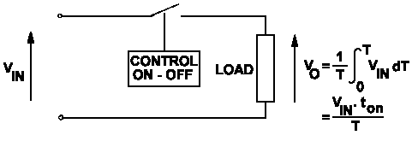
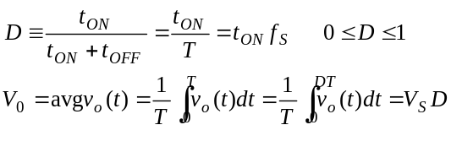

Figure 3
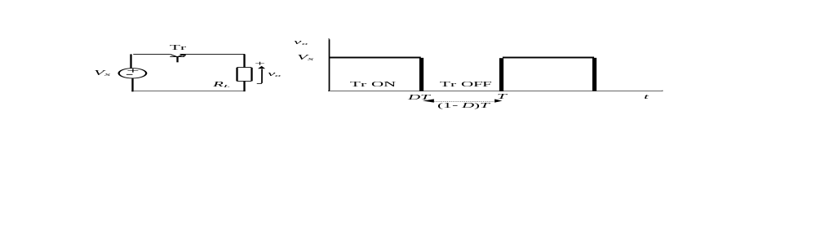
Figure 4.Relation of input/output and duty cycle in PWM method
Most loads, inductive and capacitive alike, require a much higher modulating frequency. Common modulating frequencies range from 1 kHz to 200 kHz.
PWM is a modulation technique that uses a digital circuit to create a variable analog signal.
Example application, ( control of output voltage of a Buck converter (step down converter)
Simple application (Control of a DC-DC converter with PWM method)
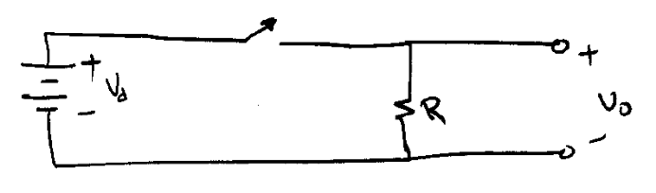
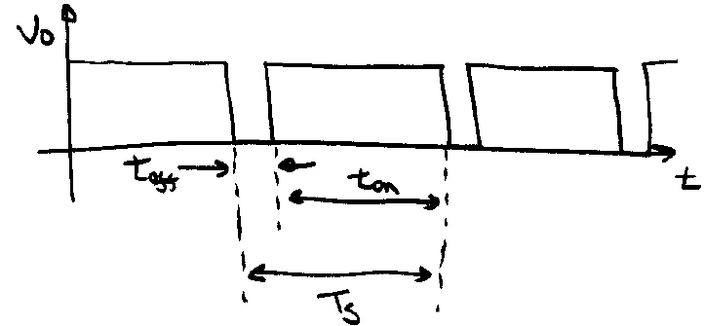

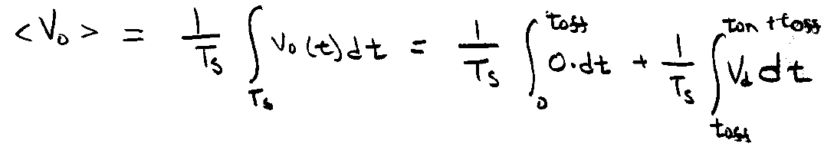
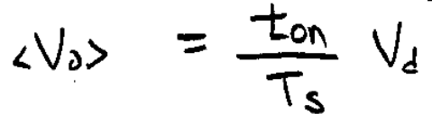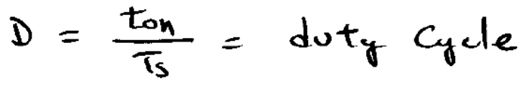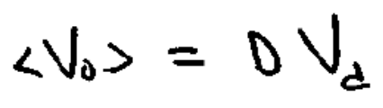
Vo depends on D not frequency: D can be changed by using PWM method:
T = Ton+ Toff
Switching frequency = 1/T, Ton changes regards to error.
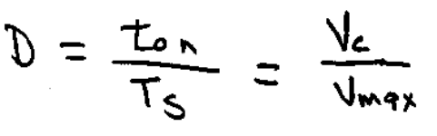
Generation of switching or control pulses:
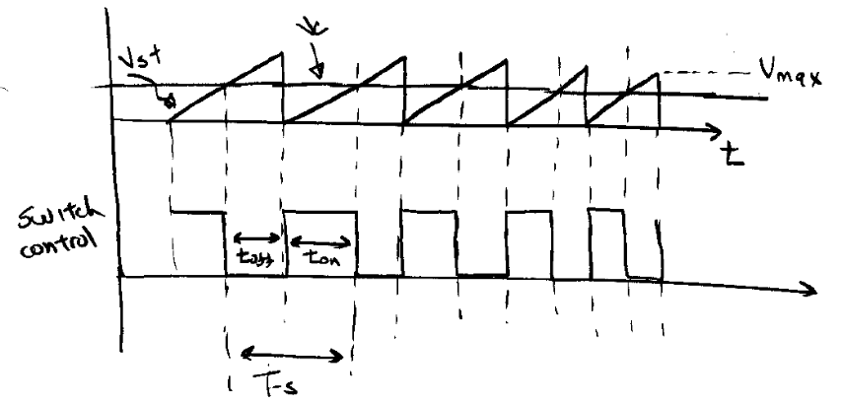
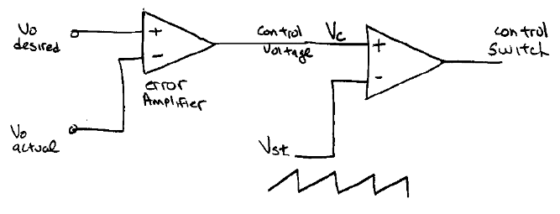
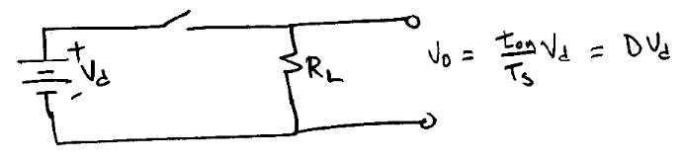
Vo has lots of ripple, add a low pass filter. When switch opens, inductor current can not go to zero instantaneously, so we add a diode
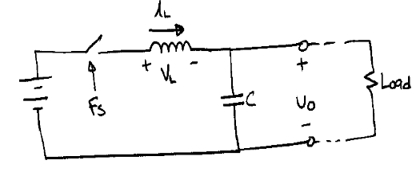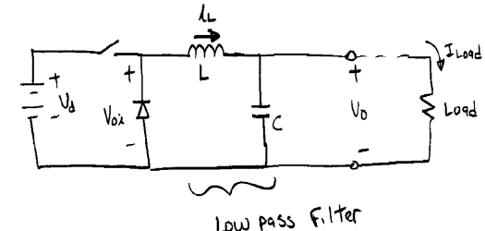

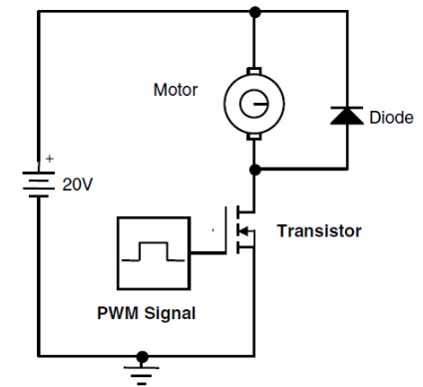
Second example: Speed control of a permanent magnet DC motor with using PWM pulses. The speed of the motor is nearly proportional
with the applied DC voltage.
PWM pulses control the switching element and change the average voltage across the motor.

PWM pulses generation methods:

1. The methods
The PWM signals can be generated in a number of ways. There are several methods:
- 1. Analogue method
- 2. Digital method (By using timers in microcontrollers)
- 3. Mixed analog-digital circuits (OP-AMP+ Flip flop)

1.1. Analogue method
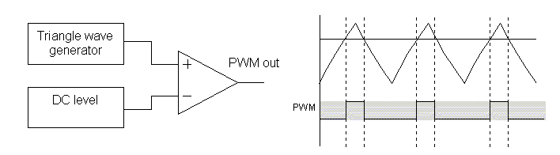
A block diagram of an analogue PWM generator is shown below:
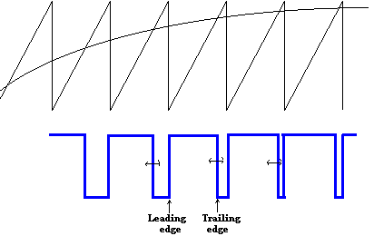

Figure 5

The simplest analog form of generating fixed frequency PWM is by comparison with a linear slope waveform such as a saw tooth (constant frequency) . As seen in Fig 5 the output signal goes high when the sine wave is higher than the saw tooth. This is implemented using a comparator whose output voltage goes to a logic HIGH when the input is greater than the other. When the triangle waveform voltage is greater than the DC level, the output of the op-amp swings high, and when it is lower, the output swings low.

PWM module in microcontrollers
Many microcontrollers include PWM controllers. For example, Microchip's PIC16C67 and 18f xx includes two and ST52X430 includes 3 PWM, each of which has a selectable on-time and period. The duty cycle is the ratio of the on-time to the period; the modulating frequency is the inverse of the period. Generation of PWM signal by using a timer. The generation of a PWM signal using an embedded controller is explained below. Use a Timer in Auto-reload mode so that it overflows at a regular interval and generates an interrupt (lts call it a software ‘tick’).

Steps of generation of PWM signal by using atimer and a register

- PWM_Output is set to set to 1 (High)
- The PWM_Counter (a register) is incremented in the Timer interrupt (ISR).
- When the PWM_Counter value exceeds dutyCycleCount, the PWM_Output is
- reset to 0. This is shown in figure
- When the PWM_Counter value exceeds MAX_count, the PWM_Output is set to 1.
0 <= dutyCycleCount <= 256
- As the PWM counter is 8 bit register, Resolution of the duty cycle is 1/256 (approximately 0.39%). PWM output is at one of the digital output port pin,
Attention: Duty ratio = On-time/ Time period.

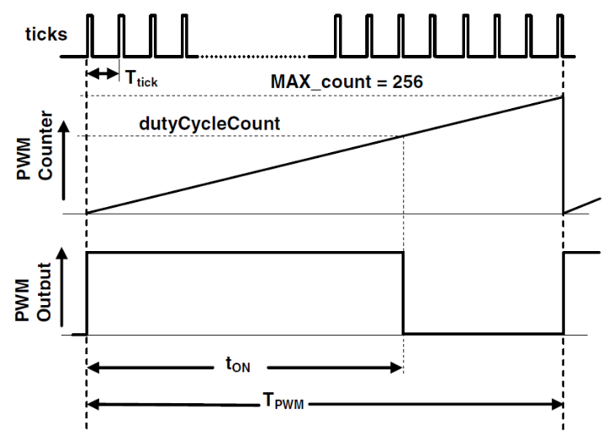
The necessary software code for the Timer_0 interrupt service routine is shown
below.
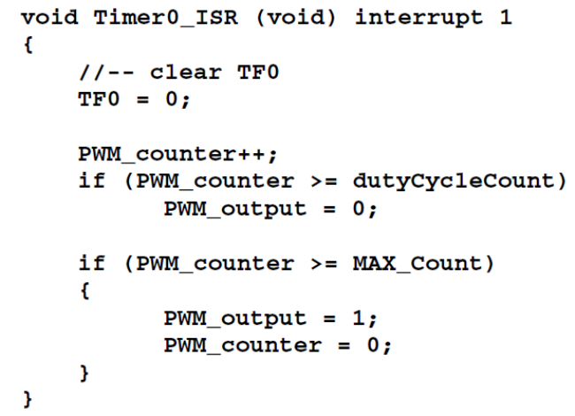
PWM Frequency: Timer 0 Reload Value

The re-load value for the timer should be correctly calculated. For a desired PWM frequency, what should be the ‘tick time’ (Ttick)?
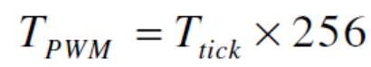
Example: If Ttick = 10 ⎧s, then,

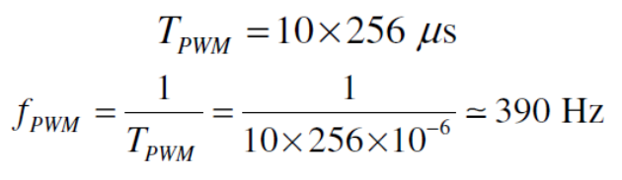
To produce an interrupt at every 10 ⎧s, what should be the reload value of Timer 0?
Using a System Clock of 22.1184 MHz,

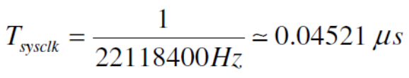
So, the number of clock pulses required is:
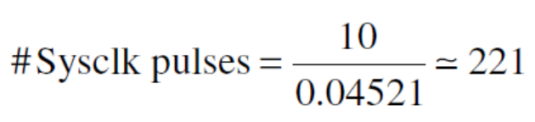
Timer 0 reload value = 255 – 221 = 34 ( The time icounting from 255 to zero)

Varying the PWM Duty Ratio (DC motor speed control or output voltage of a voltage converter )
The ADC converter is 12 bit converter.

While the control of the speed of the DC motor is tested in open loop condition, the potentiometer can be used to set the duty ratio. The PWM ON time is changed by changing the value of dutyCycleCount, which must be between 0 and 255.
Use the potentiometer as an analog input which is connected to the Analog Input
The ADC0 output is a 12-bit data (0 to 4095). In the program, read the ADC0 output and divide by 16. The pictorial representation of the whole process is shown in figure

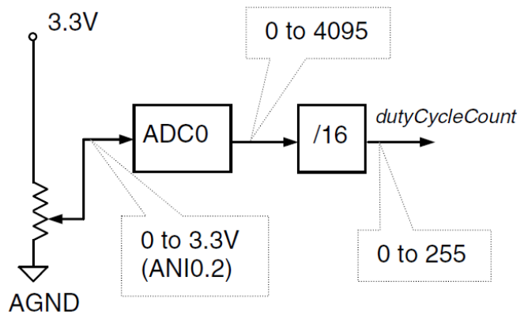
Some controllers use CCP module for generation of PWM pulses. This method is a Timer based pulsed generation similar to above method.
2. PWM as a simple DAC

Pulse Width Modulated (PWM) waveforms which are basically digital waveforms, can be used as cheap Digital-to-Analog (D/A) converters with few external components. For simple application applications do not require high resolution D/A converters., Conversion of PWM waveforms to analog signals involves the use of analog low-pass filters.
In a typical PWM signal, the base frequency is fixed, but the pulse width is a variable. The pulse width is directly proportional to the amplitude of the original unmodulated signal. In other words, in a PWM signal, the frequency of the waveform is a constant while the duty cycle varies (from 0 % to 100 %) according to the amplitude of the original signal.
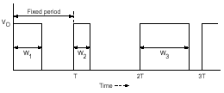
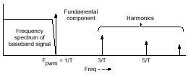

Figure 7 Figure 8

If PWM signal is passed through a low-pass filter, the output of the filter is the analog signal VOUT = K × A, where A is the amplitude of the PWM pulses, and K is the duty cycle.This is a simple and cheap D/A converter, and therefore most recent microcontrollers include a dedicated PWM timer, or have the main timer designed with the capability to generate PWM signals.. The addition of a low pass fitler to the output of pwm signals provides an analog signal .The most important thing is the relation between the time constant of the filter (t=R*C) and the period of the PWM signal. As a rule of thumb, you should dimension your R and C, so that the time constant is at about 100 times higher than the period of the signal. If your PWM frequency is 10 kHz (which means 100us period), you should choose a time constant of about 10ms – easily obtainable with R=1k, and C=10uF(easy to get values). In case you decrease the time constant with respect to the period of the PWM (say from 10ms down to 1ms), the filter will not be able to dampen the oscillations of the PWM signal, and you might end up with something like this (again, red is the output of the filter): The PWM output is then filtered to obtain acceptable ripple. The filter can be a simple low-pass filter.
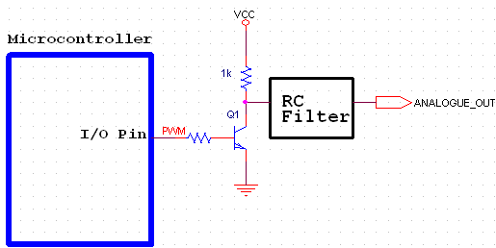
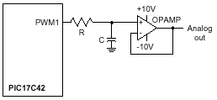

Figure 9
Analog Signal generation by using PWM module in microcontroller:
Analog signal like sine wave or triangular wave can be generated by a controller in two ways. Firstly, a table of discrete value for signal is created in memory of controller. For example sine wave table is shown in figure 11. In first way the values of table can be sends to any parallel port then converted to analog signal by any ADC converter. In this way 8 or 16 pin of microcontroller must be used. It is shown in fig 10.

Microcontroller

DAC circuit
8 bit
Sine wave

Figure 10
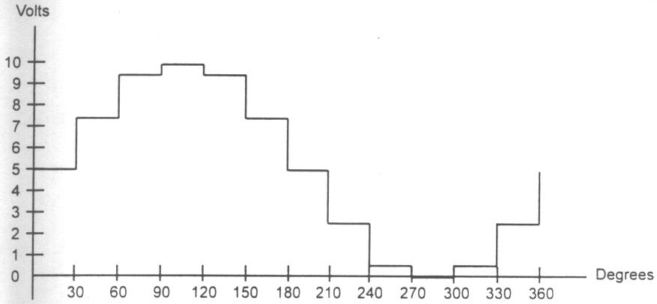

Figure 11
In the second method to generate a sine wave, we first needs a table whose values represent the magnitude of the sine of angles between 0 and 360 degrees. In this method the values of table is sent to control register of PWM module for adjusting PWM signal widths. The output of PWM module from microcontroller is only single pin and sent to low pass filter.(fig 9)

Table 1: Angle v. Voltage Magnitude for Sine Wave

Angle θ Vout(Voltage Magnitued) Valuse Sent to DAC (decimal)
(degress) Sin θ 5 V + (5V x sinθ) (Voltage Mag x 25.6)

0 0 5 128

30 0.5 7.5 192

60 0.866 9.33 238

90 1.0 10 255

120 0.866 9.33 238

180 0 5 128

210 -0.5 2.5 64

240 -0.866 0.669 17

270 -1.0 0 0

300 -0.866 0.669 17

330 -0.5 2.5 64

360 0 5 128

